8.You are tasked with developing an Online Learning Platform. The
platform should include the following functionalities:
1. Course Enrollment and Registration
2. Video Lecture Streaming
3. Interactive Quizzes and Assignments
4. Progress Tracking Dashboard
5. Peer-to-Peer Discussion Forums
6. Certificate Generation
Use Jira to categorize and prioritize these requirements using

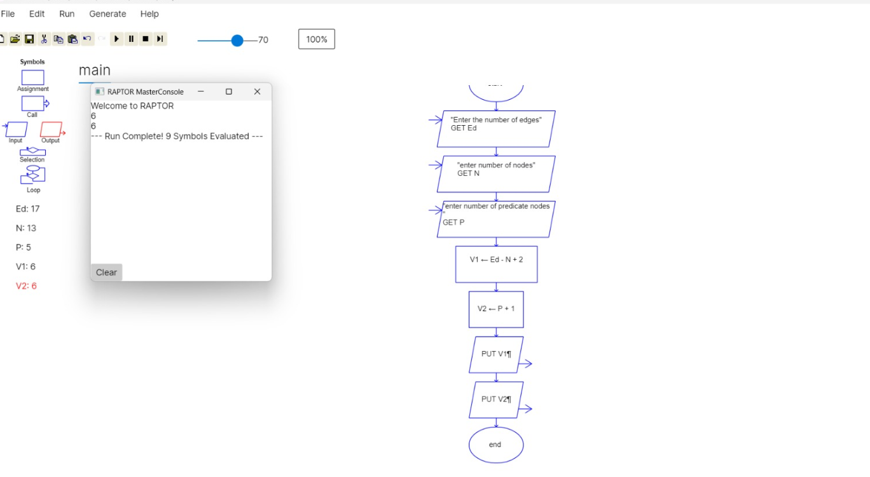

9.Demonstrate how to work collaboratively in Git/GitHub on a project
using the fork-and-pull request workflow.
Tasks:
1. Fork an existing public GitHub repository (e.g., a sample
JavaScript or Python project).
2. Clone the forked repository to your local machine using Git.
3. Create a new branch for the feature or change you want to
work on.
4. Make modifications or add new features (e.g., add a function,
fix a bug, or update the README).
5. Commit your changes and push the branch to GitHub.
6. Go to the GitHub repository and create a pull request to merge
your feature branch into the main branch.
7. Review the pull request and provide feedback on the changes.
8. Respond to feedback by making additional commits to the

Git/GitHub CO3

feature branch if necessary.
9. Once the pull request is approved, merge it into the main
branch.
10. Finally submit the link to the pull request along with a
summary of the changes you made and how you collaborated.

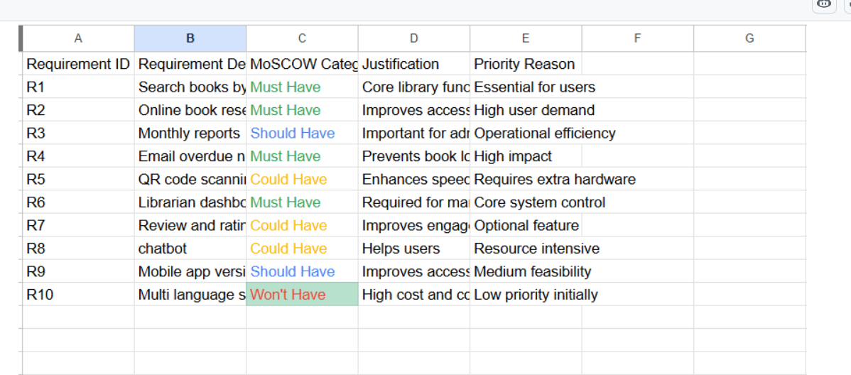
10..Demonstrate how to work with Git branches and resolve merge
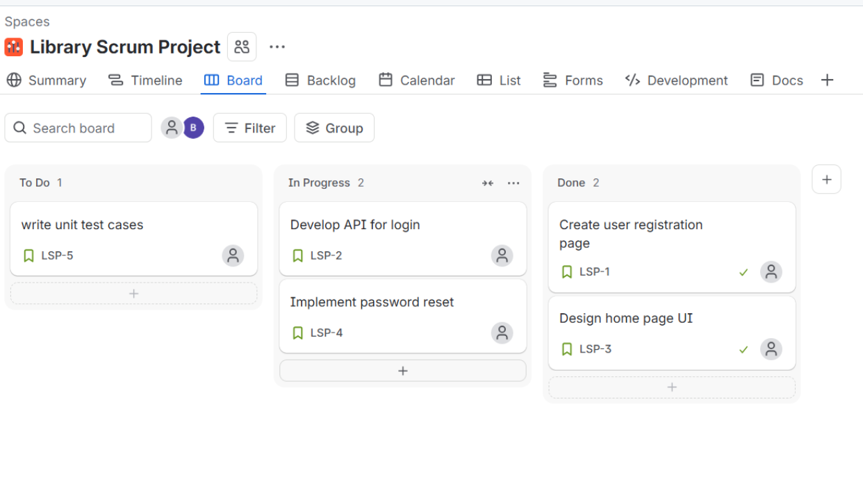
conflicts when collaborating with others.

